**Description**

From the exercise on the Mercado Pagos business unit, we expect you to develop a Machine Learning model to predict the order in a group of value proposals - aka value props- in the carousel app name ‘Descubrí Más’.



Your task is to build a pipeline using Python with their libraries. There are 3 inputs with data from different sources and the outcome should be a dataset ready to be used by the model.

**Data Sources**

* **Prints** (prints.json) a month historical data of displayed value props to the users in json lines format (a json per line), i.e:

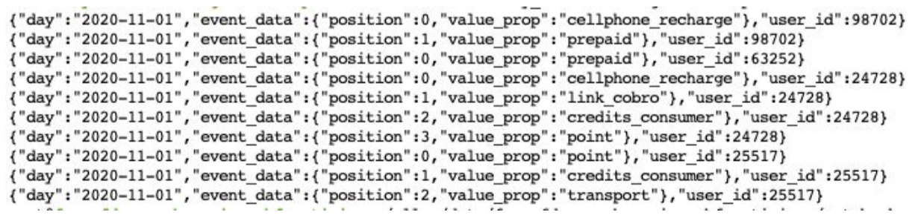

* **Taps** (taps.jason) a month historical data with the clicked value props by the users, using json lines format as well, i.e:

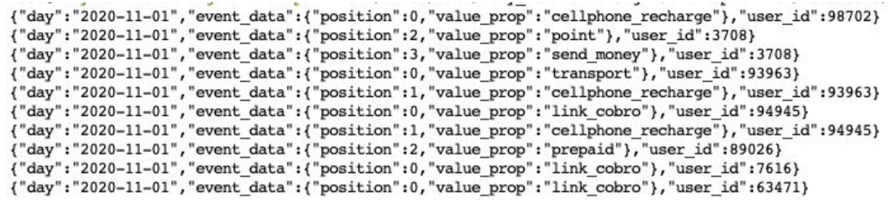

* **Payments** (pays.csv) a month historical data with payments made by users, using json lines format, i.e:

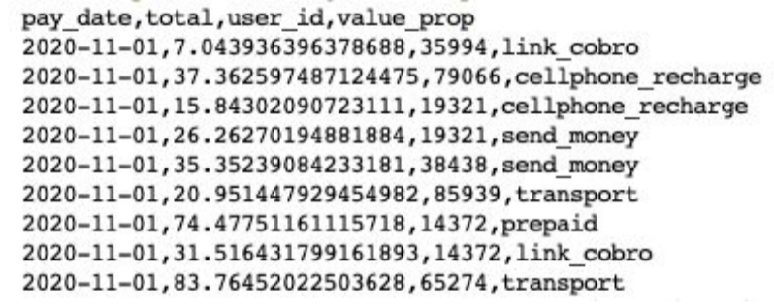

**Expected results**

The expected result must have the following information:

* Prints from the last week
* For each print:
  + A field indicating if the value props were clicked or not
  + Each of the value props views number in the previous 3 weeks to that print.
  + Number of times a user clicked on each of the value props in the previous 3 weeks to that print.
  + Number of payments made by the user for each value props in the previous 3 weeks to that print.
  + Accumulated payments made by the user for each value props in the previous 3 weeks to that print.

**Deliverable**

* Python code
* A document with a brief explanation of the decisions made